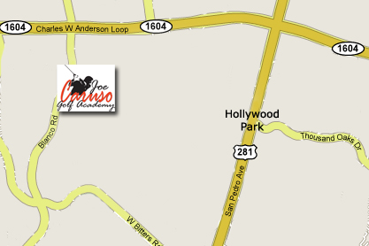

**From San Antonio International Airport:**  
Take 281 North. Exit Loop 1604 West. Turn left at the light and get on to Loop 1604 West. Exit Blanco Road. Take a left at the light on Blanco Road. Go approximately 2 miles. CGC is located on the left hand side of Blanco Road.

**OPENING DATE: February 27th**

**Come see us to see the latest products from the PGA Merchandise Show and sign up for a drawing for a new Adams F12 Driver.**

We are pleased to announce that we will be moving to Joe Caruso Golf Academy, which is located at:

16900 Blanco Road

San Antonio, Texas 78248

**Our New Location**